

Appeal to the KwaZulu-Natal MEC for ECONOMIC DEVELOPMENT, TOURISM & ENVIRONMENTAL AFFAIRS

Appeal in terms of the provisions of section 43 of the National Environmental Management Act, Act 107 of 1998 and the Environmental Impact Assessment Regulations, 2010

DETAILS of the kwazulu-natal MEC for ECONOMIC DEVELOPMENT, TOURISM & ENVIRONMENTAL AFFAIRS:
This notice may be posted, faxed, e-mailed or hand delivered to:
POSTAL/ FAX/ E-MAIL: | PHYSICAL:
Private Bag X001  Bishopsgate  4008, Durban  Tel: 031 310 5306  Fax: 031 310 5416  E-Mail:  haresh.inderlall@kznedtea.gov.za  (Haresh Inderlall) | 9th Floor, The Marine Building,  22 Dorothy Nyembe Street,  Durban  4001

(For official use only)
EIA/ Waste Management Licence/ Air Emission Licence Reference Number:
Date Received:

- DETAILS OF PROJECT
(* Provide the applicable application reference number)
EIA Reference No:/  Waste Management Licence Reference No:/  Air Emission Licence Reference No:* | DC/21/0024/2015
Project description: | Environmental authorisation for the use of alternative fuels and resources (AFR) at NPC Simuma

- ATTACHMENTS

This appeal must be accompanied by the following:
  - a statement setting out the grounds of appeal;
  - supporting documentation which is referred to in the appeal and which is not in the possession of the MEC; and
  - a statement by the appellant indicating that regulation 60(2) or (3) (as the case may be) has been complied with.

- DETAILS OF APPELLANT

Is the appellant the applicant for this project? | YES | NO x

Full names of Appellant
Mr. Euripides (Rico) Euripidou
Address of the appellant
groundWork - Friends of the Earth South Africa
6 Raven Street
P.O. Box 2375, Pietermaritzburg,3201
Telephone and fax number of the appellant
Tel: +27 33 342 5662
Fax: +27 33 342 5665
Signature of appellant
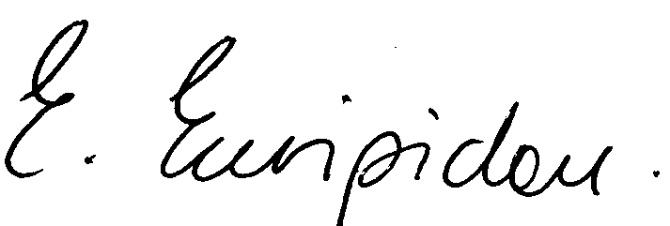

26th January 2016
Date

